TV Show 17:10, 20-Feb-2019
Amb. Huang Ping:
How New York pioneered Sino-U.S. ties

Closer to China with R.L.Kuhn

02:08
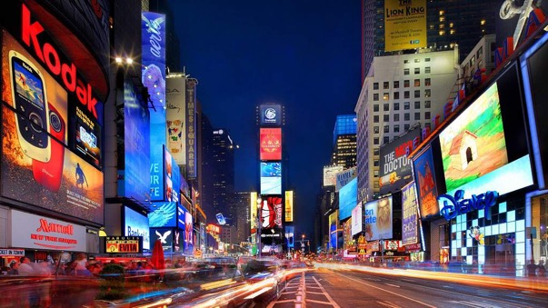
New York is one of the most populous megacities in the world, and it has been known as the cultural, financial and media center of the world, exerting a significant impact upon commerce, entertainment, research, technology, education, politics, tourism, art, fashion, and sports.
Today, with a new round of China-U.S. trade talks underway, CGTN anchor Robert L. Kuhn talks with Huang Ping, the new Chinese Consul General in New York, about the historic and crucial role that New York City has been playing on the improvement of the Sino-U.S. relationship.
Chinese Ambassador Huang stressed, during the exclusive interview, that New York City has historically contributed a lot in enhancing the China-U.S. relationship since the very beginning of bilateral ties by telling the world many historic “First Stories” about China.
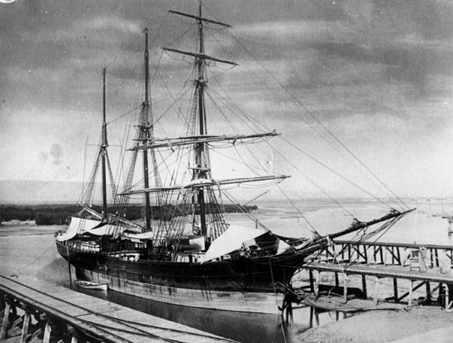
The first American cargo, named the Empress of China, set out from New York for China, February 22, 1784. /Photo by Oxford University Press

The first American cargo ship to trade with China set out from New York to Guangzhou (formerly Canton) in 1784. The merchant ship, named the Empress of China, made the 18,000-mile trip in six months and took four months to trade its cargo for tea and export porcelain. The return trip to New York lasted from May to October 1785.
Soon dozens of ships each year were plying the seas between the U.S. and China, and the desire for speed in the trade with the East gave rise to the magnificent clipper ships - the fastest sailing ships ever built - in the 1830s.
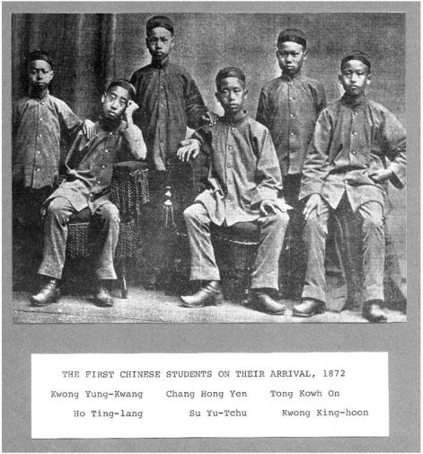
Yung Wing, one of the first Chinese students in America in 1872. /Photo by Connecticut Historical Society
The first Chinese overseas student graduated from Yale University New York in 1854. In the 1800s, an American Rev. Samuel Robbins Brown first brought three Chinese students to the U.S. after serving in Macao for eight years. Yung Wing was one of them.
He attended Monson Academy in Massachusetts and graduated from Yale University in 1854. There had not been any formal connection in education between two countries at that time.
Later, the Chinese government got in touch with Wing and began to sponsor around 120 Chinese boys, who were expected to contribute to their motherland after learning Western technology, to study in the U.S.
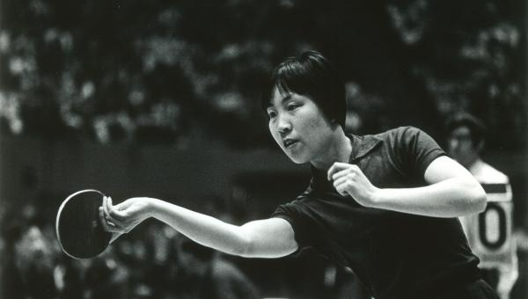
The first Chinese Ping-Pong team visiting the U.S. reached New York in April 1972. /Photo by National Committee on U.S.-China Relations (NCUSCR)

The first Chinese ping-pong delegation visited New York in April 1972, in a move widely known as Ping Pong Diplomacy. The Chinese team arrived in Detroit by chartered plane on April 12, visited Ann Arbor, Williamsburg, Washington, New York, Memphis, Los Angeles and the Bay Area, and left San Francisco on April 30.
They played six matches with U.S. teams and gave several exhibitions, all of which were enthusiastically received.
The success of the Chinese Table Tennis Team's visit opened the doors to further sports, cultural and educational exchanges in 1970s, with two sides sending and receiving delegations in many major sports including swimming and diving, basketball, gymnastics, track and field, volleyball, tennis, and soccer.
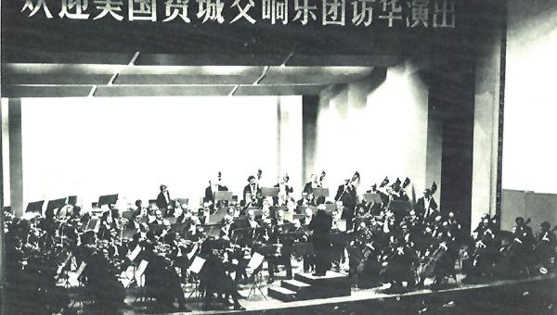
The first American orchestra to perform in China in 1973. /Photo by NCUSCR

The first American orchestra performed in China in 1973. Under the direction of maestro Eugene Ormandy, the Philadelphia Orchestra traveled to Beijing and Shanghai and gave six concerts during its two-week visit, becoming the first U.S. orchestra to travel China as a cultural ambassador.
The Orchestra performs annually at New York Carnegie Hall and enjoys a three-week summer residency at the Saratoga Performing Arts Center in New York — a venue that was built for the Orchestra.
In 2012, the ensemble reconnected with its historical roots in China by launching a new partnership with the National Center for the Performing Arts (NCPA) in Beijing.
As Amb. Huang noted, nowadays, there are many New Yorkers continuing making great achievements on the development of China-US ties.
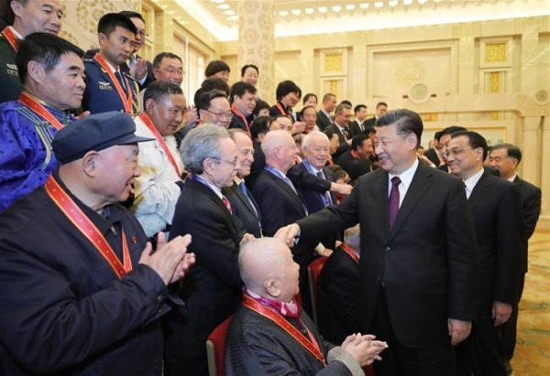
Two New Yorkers, Maurice Raymond Greenberg and Robert Lawrence Kuhn, were awarded the China Reform Friendship Medal in December 2018. / Photo by China Plus, China Radio International

On December 18, 2018, the China Reform Friendship Medal, the highest award for “foreign experts who have made outstanding contributions to the country's economic and social progress”, was awarded to 10 foreigners.
Among them are two New Yorkers – one is Maurice R. Greenberg, the past Chairman and Director of the Federal Reserve Bank of New York, now serving on the President's Council on International Activities of Yale University, and the other is Robert Lawrence Kuhn, Chairman of the Kuhn Foundation, a long-time adviser to the Chinese government, and host of “Closer To China” on CGTN.
“There are actually many first stories happening here. New Yorkers have been playing a very important role to help the China-U.S. relations to grow.” Chinese Ambassador Huang concluded, adding that under the new situation, New York, as an important place for international diplomacy, could and would play a positive, compensatory and crucial role to balance and cement Washington-Beijing ties.

https://news.cgtn.com/news/3d3d414f3245444f32457a6333566d54/index.html

