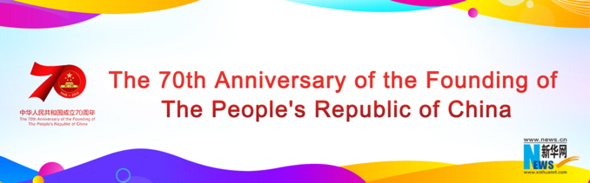

Interview: Renowned observer highlights two "historic transformations" in China's 70-year development
Source: Xinhua | 2019-10-01 09:56:49 | Editor: Xiaoxia

NEW YORK, Sept. 30 (Xinhua) -- China has made two "equally important historic transformations" in the past 70 years alongside its remarkable economic development, said a leading U.S. expert on the Asian country.
The significant changes are China's "pro-active engagement" with the world community and its "remarkable success in poverty alleviation," Chairman of the Kuhn Foundation Robert Kuhn told Xinhua in a recent interview.
"What is especially striking is the scope of China's transformations," said Kuhn, who has visited China for over 200 times in the past 30 years and was awarded China Reform Friendship Medal in December 2018.
"There was a time when China was a closed society, eschewing engagement with the world," he said. "Today, China is a champion of globalization and a bulwark of international stability through global governance."
What China exports are infrastructure expertise and development opportunities via the Belt and Road Initiative and support for the global commons through peacekeeping operations and leadership on climate efforts, he said.
"There was also a time when a significant percentage of the world's abject poor were living in China," said Kuhn. "China has brought over 750 million people out of poverty, the greatest developmental success story in human history."
China has accounted for a large percentage of the poverty reduction goals of the United Nations' 2030 Agenda for Sustainable Development, he said.
"It is the China story that must be told," he added. "When historians of the future write the chronicles of our times, a feature may well be China's targeted poverty alleviation."
As regards the remarkable economic development undergirding the two historic transformations, Kuhn said it can be attributed to a set of "driving principles."
Among them, he observed, are a people working long and hard to improve the lives of their families and the destiny of their country and a system that enforces political stability and encourages economic freedom.
Also on his list are a vision that sets long-term goals, mid-term objectives and short-term policies that are monitored and modified continuously, a way of thinking that emphasizes experimentation before implementation, and a willingness to admit and correct errors.
"The free trade zone in Shanghai was operated for three years before the free trade zones were opened in other cities, now more than a dozen, including all of Hainan Province," he noted.
Recalling his first visit to China in January 1989, Kuhn said he was "hooked" from the moment he arrived. "The Chinese had a fresh, if naive, enthusiasm; they were eager to learn, and ready to improve their civic and material lives," he said.
"I knew then that China's culture, history, economics and politics would soon come to matter a great deal to the world," he added.
http://www.xinhuanet.com/english/2019-10/01/c_138438564.htm

