

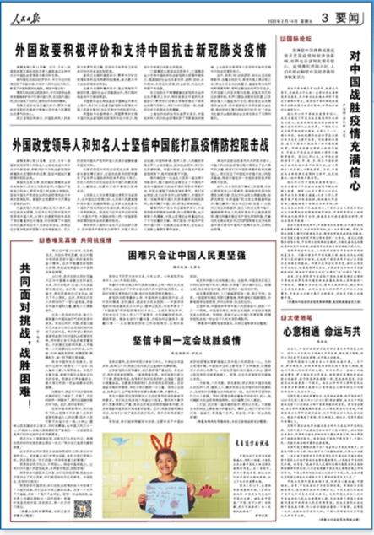

人民日报图文数据库（1946-2020）

对中国战胜疫情充满信心（国际论坛）

罗伯特·劳伦斯·库恩
《 人民日报 》（ 2020年02月14日 03 版）

我深信中国终将战胜疫情并克服疫情对经济的影响，世界也应该对此抱有信心。疫情得到控制之时，人们有理由相信中国经济将很快恢复活力

我与中国结缘已有30多年，我爱这个国家，这就是为什么我一直密切关注着新冠肺炎疫情，并不断为全球媒体评析中国应对疫情的努力。我深信中国终将战胜疫情并克服疫情对经济的影响，世界也应该对此抱有信心。
我之所以对中国战胜疫情有信心，是因为看到了中国为抗击疫情所付出的巨大投入，这首先体现在为阻止病毒传播而进行的惊人社会动员。中国政府正在采取严格而坚决措施，全国上下一心、闻令而动。如此规模的社会动员在全球公共卫生史上前所未有。它能奏效的原因，在于中国共产党领导下的中国制度优势。同样是依靠这种投入和动员能力，中国共产党在与贫困的斗争中不断取得胜利。自2012年以来，在中央政府的领导下，省、市、县、乡、村五个层级的地方政府和组织展开协调行动，全力帮助近1亿贫困人口摆脱贫困。目前，中国在抗击新冠肺炎疫情的过程中，也是依靠这一组织架构开展动员。
我之所以对中国战胜疫情有信心，还因为看到了中国在抗击疫情中释放的强大能量。拥有1100多万常住人口的大城市武汉关闭离汉通道；大量工作人员挨家挨户进行体温检测；短短数天即在空地上建起拥有千余张床位的医院；来自全国各地的医疗队驰援湖北；中国的企业尤其是国有企业全力保障抗击疫情期间物资供应；中国科学家与全球医学和流行病学专家合作，快速完成对病毒基因组测序，并与各国共享数据……
在应对疫情的过程中，中国强调及时准确、公开透明地发布疫情最新情况，回应境内外关切，这一点非常关键。其间，中国政府每天都举行新闻发布会，精确发布相关病例统计数据。不断自我完善始终是中国治理体系的一大特点。通过此次疫情防控阻击战，中国将及时吸取经验教训，不断完善信息收集反馈和决策纠错机制，推进国家治理体系和治理能力现代化。
疫情得到控制之时，人们有理由相信中国经济将很快恢复活力。只要回顾当代中国发展历程，就能充分认识到中国人民的潜力和韧性，这也是中国自改革开放以来实现历史性转变的基础。即使不是专业经济学家，我们也有充分理由相信，随着疫情得到控制，当前被暂时抑制的需求重新释放时，将推动中国经济出现“反弹式”或“补偿式”增长。
未来，历史学家很可能会把中国抗击新冠肺炎疫情的斗争视为世界范围内遏制新疾病暴发和阻止其传播的一个转折点。随着经济全球化、国际交流便利化，相应努力正变得至关重要。如何在全球化的世界中应对公共卫生事件，中国在这方面开展了全新探索，历史很可能为此感谢中国。
（作者为中国改革友谊奖章获得者、美国库恩基金会主席）

http://paper.people.com.cn/rmrb/html/2020-02/14/nw.D110000renmrb_20200214_2-03.htm

Full confidence in China's victory over the epidemic (International Forum)

Robert Lawrence Kuhn

People's Daily (February 14, 2020, 03 edition)

I am convinced that China will eventually overcome the epidemic and overcome the economic impact of the epidemic, and the world should also have confidence in this. When the epidemic is under control, there is reason to believe that China's economy will soon recover

I have been associated with China for more than 30 years, and I love this country, which is why I have been following the epidemic of new crown pneumonia closely, and I have continuously evaluated China's efforts to respond to the epidemic for the global media. I am convinced that China will eventually overcome the epidemic and overcome the economic impact of the epidemic, and the world should also have confidence in this.

The reason why I have confidence in China's victory over the epidemic is because of the huge investment China has made in fighting the epidemic, which is firstly reflected in the amazing social mobilization to stop the spread of the virus. The Chinese government is taking strict and resolute measures, and the whole country is moving up and down. Social mobilization of this scale is unprecedented in the history of global public health. The reason it works is the advantage of the Chinese system under the leadership of the Chinese Communist Party. Relying on this input and ability to mobilize, the Chinese Communist Party has continuously won in the fight against poverty. Since 2012, under the leadership of the central government, local governments and organizations at the provincial, city, county, township, and village levels have coordinated actions to help nearly 100 million poor people escape poverty. At present, China is also relying on this organizational structure to mobilize in the fight against the new crown pneumonia epidemic.

The reason why I have confidence in China's victory over the epidemic is because I see the powerful energy that China has released in the fight against the epidemic. Wuhan, a large city with more than 11 million permanent residents, closed the Li-Han corridor; a large number of staff went door-to-door for temperature testing; in just a few days, a hospital with more than a thousand beds was built on open space; medical teams from across the country helped Hubei ; Chinese enterprises, especially state-owned enterprises, are fully committed to ensuring the supply of materials during the fight against the epidemic; Chinese scientists cooperate with global medical and epidemiological experts to quickly complete the sequencing of viral genomes and share data with countries ...

应对 In the process of responding to the epidemic, China emphasizes the timely, accurate, open and transparent release of the latest situation of the epidemic, and it is very important to respond to domestic and foreign concerns. In the meantime, the Chinese government held daily press conferences to accurately release relevant case statistics. Continuous self-improvement has always been a major feature of China's governance system. Through this fight against epidemic prevention and control, China will learn lessons in a timely manner, continuously improve information collection feedback and decision-making error correction mechanisms, and promote the modernization of national governance system and governance capabilities.
When the epidemic is brought under control, there is reason to believe that the Chinese economy will soon recover. As long as we review the development history of contemporary China, we can fully realize the potential and resilience of the Chinese people, which is also the basis for China's historic transformation since reform and opening up. Even if we are not professional economists, we have every reason to believe that as the epidemic is brought under control and the temporarily restrained demand will be released again, it will promote "rebound" or "compensatory" growth in the Chinese economy.
In the future, historians are likely to see China's fight against the new crown pneumonia epidemic as a turning point in the world to curb new disease outbreaks and prevent their spread. With economic globalization and facilitation of international exchanges, corresponding efforts are becoming vital. How China responds to public health events in a globalized world, China has launched a new exploration in this regard, and history is likely to thank China for this.

(The author is the winner of the China Reform Friendship Medal and the chairman of the Kuhn Foundation of the United States)

