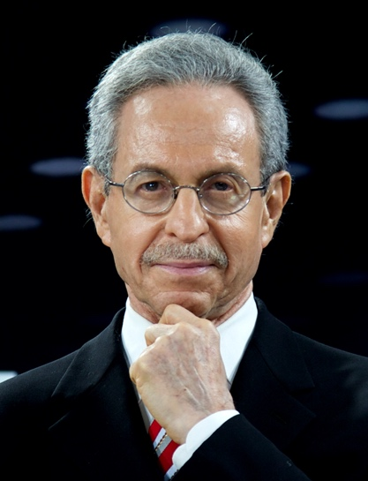

DR. ROBERT LAWRENCE KUHN, “CHINA VISION 2035: IMPACT AND IMPLICATIONS”
Dr. Robert Lawrence Kuhn is an international corporate strategist and investment banker, renown China expert, and public intellectual. He was awarded the “China Reform Friendship Medal” by President Xi Jinping on the 40th anniversary of China’s historic reform and opening up (2018). The medal honors 10 foreigners who contributed to China; five are living; Dr. Kuhn is one of two Americans. He works with world-class multinational corporations, CEOs and C-Suite, on China strategies. For 30 years, Dr. Kuhn has worked with China’s leaders and advised the Chinese government. He is a commentator on CNN, BBC, CCTV, CNBC, Bloomberg, Fox Business, and a columnist in South China Morning Post and China Daily. He is the author of over 30 books, including How China’s Leaders Think (featuring President Xi Jinping) and The Man Who Changed China: The Life and Legacy of Jiang Zemin (China’s best-selling book of 2005). As an investment banker, Dr. Kuhn worked on public market acquisitions (including hostiles) and advised Japanese companies. He was president/co-owner of the largest middle-market M&A firm in the U.S.; sold to Citigroup (2001), after which he was Senior Advisor to Citigroup. Dr. Kuhn is chairman of The Kuhn Foundation; and creator/host of Closer To Truth, the long-running PBS / public TV series on science and philosophy. He has a Ph.D. in anatomy/brain research (UCLA) and an MBA (MIT).

https://econclubnashville.org/events-test/dr-robert-lawrence-kuhn-china-vision-2035-impact-and-implications/

Attendance: About 50 business and civic leaders of Nashville, Tennessee

FEEDBACK

From: Donald McKenzie <DMcKenzie@maynardcooper.com>
Sent: Tuesday, January 12, 2021 1:07 PM
To: Byrd, Damon <dbyrd@aintreecap.com>

Damon,
Thank you for bringing Dr. Kuhn to today’s meeting – brilliant. One of the best presentations I have heard.
Donald
Donald McKenzie
Shareholder | Corporate, Securities & Tax
P: 615.916.3221
DMcKenzie@maynardcooper.com | V-card
____
From: Chris Simonsen <chris@christophersimonsen.com>
Sent: Tuesday, January 12, 2021 1:12 PM
To: Byrd, Damon <dbyrd@aintreecap.com>; Cayla O'Leary <director@econclubnashville.org>
Subject: Re: ECON

Fantastic meeting!!!
Yours to count on,
Chris Simonsen
Fridrich and Clark Realty, LLC

From: Javier Solano <jsolano@mpf.com>
Sent: Tuesday, January 12, 2021 3:50 PM
To: Byrd, Damon <dbyrd@aintreecap.com>

That was outstanding, Damon. Dr. Kuhn was brilliant. Thanks for the push here and for connecting him (I’m guessing) to us.

Best

Javier

Javier Solano | MP&F Strategic Communications
(o) 615.259.4000 | (c) 615.330-2817 | @mpfcomm | mpf.com
CitySpace, 611 Commerce Street, Suite 3000
Nashville, TN 37203

