ROBERT MARSTON CORPORATE COMMUNICATIONS, INC.

CNBC “Invest China” – January 17, 2011

China will prosper under the leadership of Xi Jinping, the likely successor of President Hu Jintao, says Robert Lawrence Kuhn—corporate strategist, long-time adviser to the Chinese government, and author of "How China's Leaders Think". He shares his thoughts with CNBC's Oriel Morrison and Martin Soong.

Martin Soong (Host):
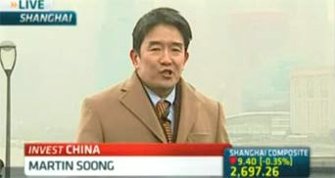
A lot of China watchers are already looking ahead to 2012, to the man who will take over from Hu Jintao—Xi Jinping—and wondering what that is going to mean for China and for the rest of the world. For some insight, we have Robert Lawrence Kuhn with us. He is the author of the book “How China’s Leaders Think.” He is a long-time China watcher, and he joins me right now.
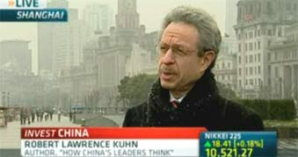
Robert, it’s great to see you. And thank you for your time. Kuhn:
Hi, Martin.

Soong:
How much do we know about Xi Jinping?

Kuhn:
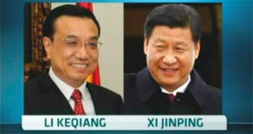
We know a good deal. He comes from a distinguished family. His father was one of the founders of New China and a true reformer under Deng Xiaoping. He was also imprisoned by Mao Zedong for many years and suffered during the Cultural Revolution. And because of that, Xi Jinping, in his early life, also suffered during the Cultural Revolution. But his experiences in remote mountainous areas put him in touch with the people.

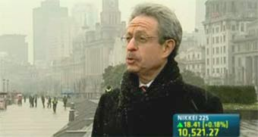
And then during his career, Xi made steady advances at all levels of government, including running Zhejiang Province [as Party Secretary], which, as you know, is the center of entrepreneurship in China. And Xi’s success was studied by central authorities [Chinese Academy of Social Sciences] as the “Zhejiang Model”—six volumes on how entrepreneurship works. So I expect Xi Jinping to be a leader who is very business-oriented, rooted in patriotism for his country, and perhaps, more of a personality than we’ve seen.

Soong:
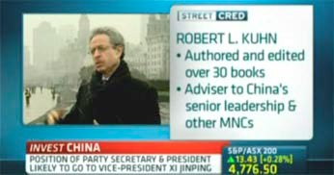
Okay. This is interesting. He’s also known, or thought to be, pro-Soviet. How’s that going to play out?

Kuhn:
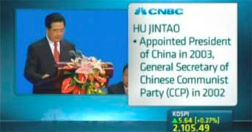
No, that’s not the case. Xi is very sophisticated. He understands the way the world works. In his early career, he served for two years in the military (in an administrative capacity), which differentiates Xi from President Jiang Zemin and President Hu Jintao, neither of whom had military experience [prior to assuming the presidency]. So because of his background, he’s had very broad experiences. He has friendships with many Westerners, so I think that we’re going to find an urbane, sophisticated leader.

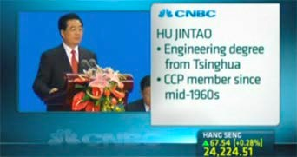
It’s also important to recognize that as China has developed, the senior leader is no longer as overwhelmingly dominant in the way leaders used to be—Mao was way up here, and then Deng, and even Jiang Zemin and Hu Jintao. You now have more of a collegial atmosphere. So Vice President Xi Jinping will become president, in all likelihood, but the other leaders who will be with him in China’s collective leadership are all individually very strong personalities as well. So China’s new generation of leaders will be an intelligent and interesting group that I look forward to.

Soong:
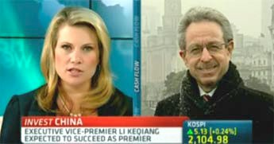
More collective leadership. Oriel, come in on this.

Oriel Morrison (Host):
Marty, thank you.
Communist era.
could well be the weakest leader when it comes to the
opinion, certainly out there from analysts, that Xi Jinping
research on this, and it does look like there is a sense of
Robert, Oriel here in Sydney. I’ve done some

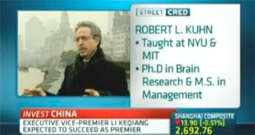
We’re talking about a change, obviously, in terms of government. How do you think this change will impact China’s relationship with some of the major economies and major powers in the world, like the U.S.—given we’ve got Hu Jintao over in Washington later on today?

Kuhn:
Well, first of all, we hope the diplomatic climate in Washington is a lot warmer than the physical climate here in Shanghai. But I think it’s a mistake to say that Xi Jinping will be the weakest leader. That really misunderstands everything that’s been

ROBERT MARSTON CORPORATE COMMUNICATIONS, INC.
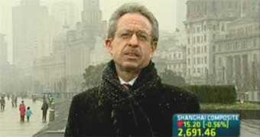
help that to happen.
a substantial and normal country, and we all want to work to
quite a positive development that China has been maturing into
happening in China—frames it negatively—when in reality, it is

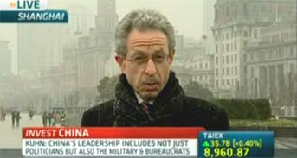
And so, I look for better international relationships in the future. I look for a strong patriotic country, a China that will stand up on many issues, particularly on economic issues—but above all, a China that must focus domestically on serving its own people. That’s leadership’s primary objective. China is still, on a per capita basis, one of the poorest countries in the world, and therefore, China’s leaders must continue to focus domestically. Overall, I look forward to a sophisticated China in the years ahead.
governmental reform that’s happening in China today.
because it mischaracterizes the administrative and
called “weakness” that some people say, is a misnomer,
is sophisticated, knowledgeable, experienced, and the so-
happens in two years, will be part of this maturing process. He
And Xi Jinping’s accession [to China’s top posts], if that

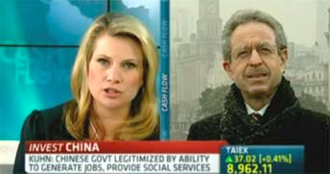
Morrison:
Is there going to be, then, more cohesion, Robert, in the way that decisions are made between China and, for example, the U.S.? Because there’s been a lot of frustration coming from the U.S.’s part. They’ve spoken to China about various issues, and they haven’t had a result. You know how this ruling power actually works, and the relationships and the influences required to get these decisions across the line.

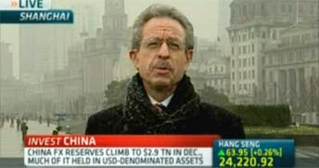
Kuhn:
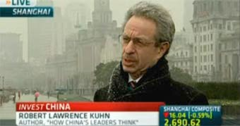
People talk about the decision process, but I don’t think that’s the major issue. The major issues are the facts of the specific matters themselves. One has to look at each individual issue, but not always in some global strategic way. What is the issue? Is the issue China’s currency? Is the issue Korea? South China Sea? Human rights? Each is a specific issue, and one cannot always make some overall generalization. One can make overall generalizations about how the government is being structured and being managed in terms of the leaders at any given time. That’s an interesting analysis, but people who are unsophisticated about how China works can confuse, and confound, the two together. You have to consider each individual issue separately—see why each is an issue at the time and what are possible resolutions. Plus, you have to look at the overall structure of leadership during the different terms

of office, like President Jiang Zemin and President Hu Jintao, and in the future, likely, President Xi Jinping.

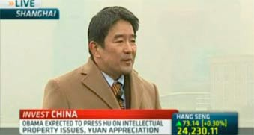
Soong:
You know, Robert, having said that though, there is one overriding concern strategically, especially for the U.S., and that is, what are China’s intentions? Is it territorial? Is it expansionist? Because as China goes abroad to try and secure supply chain, it’s raising not just corporate hackles, but political concerns. Bob Gates, the rest of the Pentagon, the
U.S. defense establishment, is getting worried. Is it territorial? Is it expansionist?

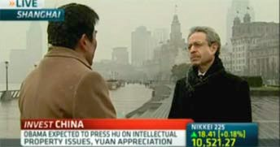
Kuhn:
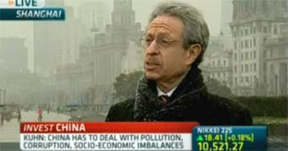
A basic principle to understand China is that the Chinese people believe, and China’s leaders believe, that in every area of human endeavor, China wants to be among the world leaders. That affects every industry; it affects culture, sports, the space program… you name it. It’s patriotism; it’s pride; it’s looking to the past, the greatness of China’s civilization; it’s the humiliation by foreigners for over 100 years; it’s China’s emergence now; and it’s China in the future becoming one of the world’s great powers in all areas. That’s the way to think.

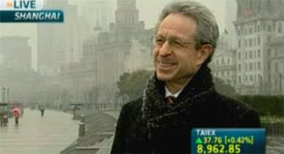
But look internally: China has to worry about its own people, because the only legitimacy that the Party has—the single ruling party—is to increase the people’s standard of living and to improve their welfare. Without such betterment, the Party has no legitimacy to power. They know that. They’ve said that. And so here’s the critical thing: China’s leaders do everything they do based on what they believe is good for China, particularly in terms of the domestic economy, in terms of the people’s standards of living. But don’t minimize the other factor—the pride of Chinese civilization. You must have both.

Soong:
Alright. Interesting points, Robert. Great to talk to you. Wish we had more time. We’ll do it again soon, I hope.

Kuhn: I look forward to it.

Soong: We’ve been talking to Robert Lawrence Kuhn, author of the book “How China’s Leaders Think” here in Shanghai.

http://classic.cnbc.com/id/15840232?video=1749050647&play=1

