Media & Culture I Entertainment

“Closer To Truth” Exceeds 200 Million Minutes Watch Time in 2021
By Daniel Lee
01/20/22 AT 7:30 PM

- The quest for answers to “big questions” of existence, universe, meaning has endured throughout human history

- Closer To Truth features leading scientists and philosophers, the greatest thinkers exploring the deepest questions

- The series has grown dramatically during the pandemic, exceeding 200 million minutes of watch time in 2021

Since earliest times, human beings have pondered life’s mysteries, assessing the world in which we find ourselves and delving into the depths of human consciousness in search of higher truth and true meaning. With the world undergoing pivotal shifts, and with the boundaries of our norms and comfort zones being pushed, we need now more than ever to discern the “big questions” in science and philosophy.
Intellectuals are questioning the foundations of reality; they are looking to go beyond our current knowledge. In fact, we all seek answers and yearn to achieve true understanding, and the pandemic, it seems, has amplified these perennial desires.
Closer To Truth is a series that explores human sentience and raw existence. It is a definitive internet archive on Cosmos (cosmology/universe, philosophy of science), Consciousness (brain/mind, philosophy of mind) and Meaning/God (theism / atheism / agnosticism, philosophy of religion).
Given the show’s high-level content, why has its global impact grown dramatically in the last two years? Sure, during the pandemic, with lockdowns and working from home, people have more time to watch. But is there more? With life altered and death present, people are asking themselves long-standing questions in philosophy, science, and religion.
Through the lens of open-minded critical thinking, Closer To Truth episodes and videos feature world-leading thinkers in intimate conversations on cosmos, consciousness and meaning/God — philosophers, physicists, mathematicians, psychologists, biologists, theologians, artists. They present diverse, impassioned views, sharing latest thinking, personal perspectives, and the challenges of facing the beauty and complexity, good and evil, mystery and majesty that compose and express the human condition.

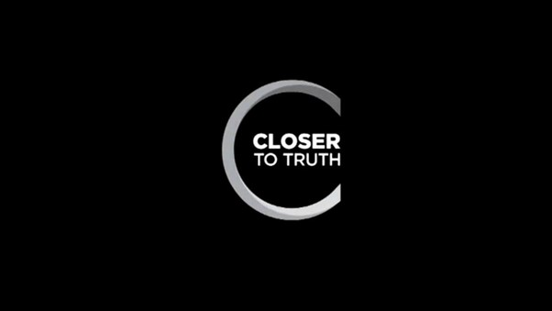

Looking “Closer To Truth”

Closer To Truth is broadcast weekly on PBS and other high-quality public television stations across the U.S and has been on the air continuously since 2000. Robert Lawrence Kuhn, who is the show’s creator, host, writer and executive producer, is an author with a Ph.D. in brain research (UCLA) as well as an MBA (MIT). Peter Getzels, who is is the show’s co-creator and producer/director, is a filmmaker trained in anthropology.

Kuhn says that “Closer To Truth’s explorations of cosmos, consciousness and meaning unify members of diverse religions, regions, races, nationalities, ethnicities, genders, ages, educational levels, income levels, and social class, and perhaps can play a small part in finding harmony in a fractious world.” CTT is appreciated by both theistic and atheistic audiences, Kuhn says, recommended by opposing camps related to God’s existence or non-existence (and this may be unique in media).

For 22 years, Closer To Truth has held its spot on-air, in comparison to similar shows such as Through the Wormhole, hosted by Morgan Freeman, that ran from 2010 to 2017. In 2021, the Closer To Truth YouTube channel exceeded 200 million minutes of watch time, with 20 million of those coming from the UK alone, which is noteworthy considering its intellectual content. The show’s views and watch time increased five-fold from 2019 to 2021.

To put this into perspective, in 2019-2020 CBS’ “Young Sheldon” was the most-watched comedy in primetime, with 11.4 million viewers per week. Since then, the show has seen a steady decline with just 6.7 million total viewers in 2021. By contrast, the Netflix record-breaking show, Money Heist, scored 34 million viewers in 2019, 65 million in 2020, and nearly 190 million in 2021.

What are Some of Philosophy's Most Asked Questions?

Truth seekers who understand the importance of self-awareness and variegated knowledge appreciate how rewarding it is when things finally “click”. Epiphanies occur as a result of constant questioning and research, which is why philosophers have always emphasized the importance of acquiring new knowledge. In fact, Plato himself suggested that if one is not a critical thinker then one is in an unhealthy place; ignorance is not bliss.
When we ask the question “why?” we open our minds to never-ending knowledge, an expanse of information beyond our imaginations. Although “why questions” can frustrate, they are key to revealing deep structure and connections, perhaps meaning, even purpose — if there is any. And this is the reason that “why?” is the critical question.
Closer To Truth asks “why questions” on fundamental topics, notably:

● Cosmos
How vast is the universe?
How did it begin?
Is it fine-tuned for life?
Are there multiple universes?
What is time?
Is time travel possible?
Where are all those aliens?
Could our universe be fake?
What is the far future of our universe?

● Consciousness
Why is consciousness so mysterious?
What is the mind-body problem?
Can brain explain mind?
What is the self?
Do we have free will?
How does personal identity persist through time?
What are dreams about?
What would transhuman brains mean?
Do persons survive death?

● Meaning
Is there purpose in the cosmos?
What causes religious belief?
Does God make sense?
Does evil disprove God?
What are alternative concepts of God?
Do science and religion conflict?
Asking ultimate questions
Why is there anything at all?
The mystery of existence

Suggested Video: https://www.youtube.com/results?search_query=closer+to+truth

Final Take

While we may not ever be able to resolve all of life’s great mysteries, we must continue to ask profound questions, think critically, and keep an open mind. While enlightenment may be a theoretical concept, by seeking truth we are already on the path of existential understanding. Platforms such as Closer To Truth make best thinking accessible, thereby facilitating the journey.

Closer To Truth will be going back into full television and video production in 2022, much of which will be within the United Kingdom and will focus on the global philosophy of religion, philosophy of biology, art seeking understanding, eastern traditions, and other “big questions”.

https://www.ibtimes.com/closer-truth-exceeds-200-million-minutes-watch-time-2021-3379997

