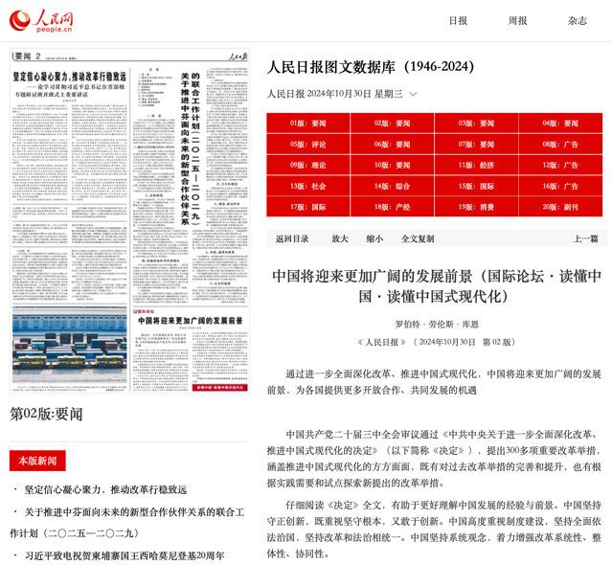

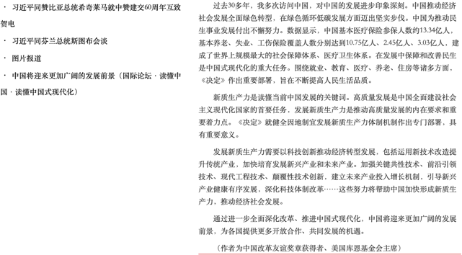

http://paper.people.com.cn/rmrb/html/2024-10/30/nw.D110000renmrb_20241030_7-02.htm

